Data Storage procedure (my proposal)

Step 1: Write the shot data to local storage
Labwindows creates a comma-seperated-variable file containing the data from each instrument and stores it D:/ and RAID. The file name is the MDS identifier for the instrument and prepended with the shot number.
Column names are taken from labwindows field entries in the device .uir file so the result for bdot is
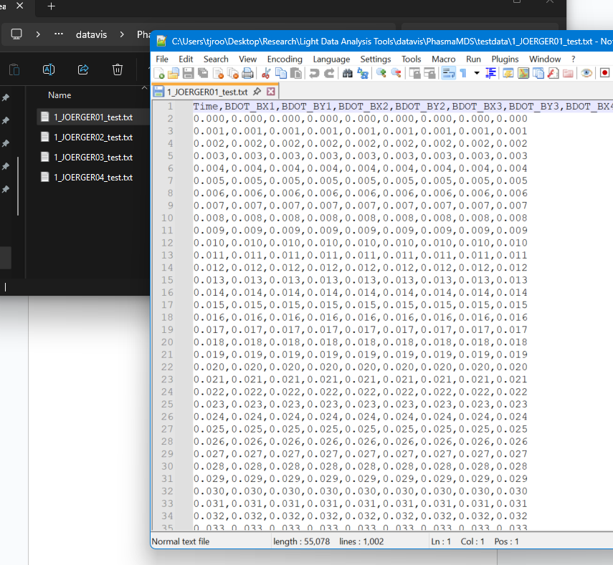
Step 2: Push the local data to MDS

The mds tree has the structure
TOP:
DEVICES
Joerger1
Joerger2
MSO5104,etc
DIAGNOSTICS
Magnetics
BdotX1, Y1, etc
Housekeeping
Bias current,voltage etc
ANALYSIS
Magnetics
Bdot_integrate.py
Python script (mds_push_all) gathers the files with the latest shot number and writes them to mds. Each physical data acquisition device has its own tree under \TOP:DEVICES. Hardware specific metadata is stored here (sample rate, bit depth, whatever else might be worth knowing)
A separate top-level tree (\TOP:DIAGNOSTICS) is intended to collate all the channels for a given diagnostic system. In this case it would contain all the bdot channels.

The goal of the separate top-level trees is to make it more obvious how each system on Phasma is implemented and what the intent of that system is (eg, a new student might not care how the bdot data is collected, so they don’t need to know about the Joergers, but someone else debugging/maintaining the system will appreciate the explicit mapping of channels to instruments).

Only TOP:DEVICES really holds any data; DIAGNOSTICS will just have channel maps and metadata (eg, calibration constants, conversion factors etc).
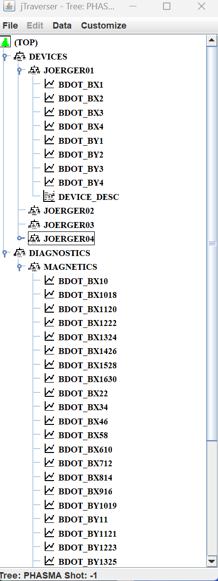
A third top-level tree (\TOP:ANALYSIS) contains the links to the analysis code for each diagnostic which will be called by piscope. These can be as simple as TDI expressions (what Jscope uses) or links to whole python scripts. I haven’t started this part and we can use Jscope in the meantime.

